Semester One Examination, 2024

Question/Answer booklet

MATHEMATICS METHODS
UNIT 3

Section One:

Calculator-free

Your Name:
Your Teacher’s Name:

Time allowed for this section
Reading time before commencing work: five minutes
Working time: fifty minutes

Materials required/recommended for this section
To be provided by the supervisor
This Question/Answer booklet
Formula sheet

To be provided by the candidate
Standard items: pens (blue/black preferred), pencils (including coloured), sharpener, correction fluid/tape, eraser, ruler, highlighters

Special items: nil

Important note to candidates
No other items may be taken into the examination room. It is your responsibility to ensure that you do not have any unauthorised material. If you have any unauthorised material with you, hand it to the supervisor before reading any further.

Question | Marks | Max | Question | Marks | Max
1 |  | 9 | 5 |  | 11
2 |  | 8
3 |  | 4
4 |  | 14

Structure of this paper

Section | Number of questions available | Number of questions to be answered | Working time (minutes) | Marks available | Percentage of examination
Section One:  Calculator-free | 6 | 6 | 50 | 53 | 35
Section Two:  Calculator-assumed | 10 | 10 | 100 | 100 | 65
 |  |  |  | Total | 100

Instructions to candidates

- The rules for the conduct of the Western Australian Certificate of Education ATAR course examinations are detailed in the Year 12 Information Handbook 2019. Sitting this examination implies that you agree to abide by these rules.

- Write your answers in this Question/Answer booklet.

- You must be careful to confine your answers to the specific questions asked and to follow any instructions that are specific to a particular question.

- Additional pages for the use of planning your answer to a question or continuing your answer to a question have been provided at the end of this Question/Answer booklet. If you use the space to continue an answer, indicate in the original answer space where the answer is continued, i.e. give the page number.

- Show all your working clearly. Your working should be in sufficient detail to allow your answers to be checked readily and for marks to be awarded for reasoning. Incorrect answers given without supporting reasoning cannot be allocated any marks. For any question or part question worth more than two marks, valid working or justification is required to receive full marks. If you repeat any question, ensure that you cancel the answer you do not wish to have marked.

- It is recommended that you do not use pencil, except in diagrams.

- The Formula sheet is not to be handed in with your Question/Answer booklet.

Section One: Calculator-free (53 marks)

This section has six questions. Answer all questions. Write your answers in the spaces provided.

Spare pages are included at the end of this booklet. They can be used for planning your responses and/or as additional space if required to continue an answer.
● Planning: If you use the spare pages for planning, indicate this clearly at the top of the page.
● Continuing an answer: If you need to use the space to continue an answer, indicate in the original answer space where the answer is continued, i.e. give the page number. Fill in the number of the question that you are continuing to answer at the top of the page.

Working time: 50 minutes.

Question 1 (9 marks)
Determine the following:

(a) $\begin{matrix}d \\ \overline{dx}\end{matrix}\left(\begin{matrix}1 \\ \overline{ {1+e}^{-2x} }\end{matrix}\right)$. (2 marks)
Solution
$$\begin{matrix}{2e}^{-2x} \\ \overline{ ({{1+e}^{-2x})}^{2} }\end{matrix}$$
Specific behaviours
ü correct numerator
ü correct denominator

(b) $\int_{0}^{\frac{1}{2}}{\underset{ }{x+\cos{(πx)}}}dx$. (2 marks)
Solution
$${\left[\frac{x^{2}}{2}+\frac{\sin\left(πx\right)}{π}\right]}_{0}^{\frac{1}{2}}=\frac{1}{8}+\frac{\sin\left(\frac{π}{2}\right)}{π}$$
$$= \frac{1}{8}+\frac{1}{π}$$

Specific behaviours
ü eliminates fraction
ü correct antiderivative

(c) $\int_{1}^{3}{\begin{matrix}d \\ \overline{dx}\end{matrix}\left(\begin{matrix}x^{4} \\ \overline{ x^{2}+1 }\end{matrix}\right)}dx$. (3 marks)
Solution
$${\left[\frac{x^{4}}{x^{2}+1}\right]}_{1}^{3}=\frac{3^{4}}{3^{2}+1}-\frac{1^{4}}{1^{2}+1}=\frac{81}{10}-\frac{1}{2}$$

$$=\frac{76}{10}$$
Specific behaviours
ü determines the correct expression for the integral
ü substitutes correct values for the two limits
ü calculates the correct value for the integral

(d) $\begin{matrix}d \\ \overline{dx}\end{matrix}\int_{2}^{x^{2}}{\underset{ }{\begin{matrix}4 \\ \overline{ 5t+1 }\end{matrix}}}dt$. (2 marks)

Solution
$$\begin{matrix}4 \\ \overline{ 5\left(x^{2}\right)+1 }\end{matrix}\left(2x\right)$$
$$=\begin{matrix}8x \\ \overline{ 5x^{2}+1 }\end{matrix}$$

Specific behaviours
ü Uses the fundamental theorem of calculus and applies chain rule
ü determines the simplified expression for the derivative

Question 2 (8 marks)
A business operates three machines. The random variable $X$ is the number of these machines that break down during a production run. The variance of $X$ is $0.3811$, and its probability distribution is shown in the table below, where $k$ is a constant.

$$x$$ | $$0$$ | $$1$$ | $$2$$ | $$3$$
$$P(X=x)$$ | $$0.74$$ | $$0.2$$ | $$k$$ | $$0.01$$

(a) Determine the value of $k$. (1 mark)
Solution
$$0.74+0.2+k+0.01=1⇒k=0.05$$

Specific behaviours
ü correct value

(b) Calculate $E\left(X\right)$. (1 mark)
Solution
$$E\left(X\right)=0\left(0.74\right)+1\left(0.2\right)+2(0.05)+3\left(0.01\right)=0.33$$

Specific behaviours
ü correct mean

(c) Determine the probability that in just three of the next five production runs, exactly one machine will break down. (3 marks)
Solution
$$Y\sim B(5, 0.2)$$
$$P\left(Y=3\right)=\left(\begin{matrix}5 \\ 3\end{matrix}\right){\left(0.2\right)}^{3}{\left(0.8\right)}^{2} \\ =10×0.008×0.64=\frac{10×1×1×1×4×4}{5×5×5×5×5} \\ =0.0512=\frac{32}{625}$$

Specific behaviours
ü indicates parameters of binomial distribution
ü correct expression for probability
ü correct probability 0.0512 or simplified fraction of integers

The random variable $T$ is the time in minutes lost to the business when a machine breaks down and is related to $X$ by the formula $T=10X+25$.

(d) Determine $P(T≤45)$. (1 mark)
Solution
$$P\left(T≤45\right)=P\left(X≤2\right)=1-0.01=0.99$$

Specific behaviours
ü correct probability

(e) Determine the mean and variance of $T$. (2 marks)
Solution
$E\left(X\right)=10×E\left(X\right)+25=10\left(0.33\right)+25=28.3$ minutes.

$\operatorname{Var}\left(T\right)={10}^{2}×\operatorname{Var}\left(X\right)=100×0.3811=38.11$ minutes squared.

Specific behaviours
ü correct mean
ü correct variance
Note: no units needed

Question 3 (4 marks)
An archer fires an arrow at a target $n$ times. The probability, $p$, of archer hitting the target is constant and all shots are independent.
Let $X$ be the number of times archer hits the target in the $n$ attempts.
The mean of X is 3.6 and the standard deviation is 1.8.
- State the distribution of $X$? (1 mark)
Solution
Binomial or $X\sim Bin(n,p)$

Specific behaviours
ü correct distribution

- Determine the values of $n$ and $p$. (3 marks)
Solution
$$np=3.6$$
$$np\left(1-p\right)={1.8}^{2}$$

$$1-p=\frac{1.8×1.8}{3.6}=\frac{1.8}{2}=0.9⇒p=0.1$$

$$0.1n=3.6⇒n=36$$

Specific behaviours
ü writes pair of simultaneous equations
✓ correct value of $p$
✓ correct value of $n$

Question 4 (14 marks)
The function $f$ is defined for $0≤x≤3.5$. Its graph has a single point of inflection and is a smooth continuous curve that passes through the points $(0.5, 0)$ and $(3, -1)$.
Information about the function is shown in the table below, where $F\left(x\right)=\int_{0}^{x}{\underset{ }{f(t)}}dt$.

$$x$$ | $$0$$ | $$0.5$$ | $$1$$ | $$1.5$$ | $$2$$ | $$2.5$$ | $$3$$ | $$3.5$$
$$f'(x)$$ | $$19$$ | $$7.5$$ | $$3$$ | $$0$$ | $$-2.5$$ | $$-4.5$$ | $$0$$ | $$60$$
$$f''(x)$$ | $$-37$$ | $$-14$$ | $$-7$$ | $$-5$$ | $$-5$$ | $$0$$ | $$30$$ | $$290$$
$$F(x)$$ | $$0$$ | $$-1.2$$ | $$-0.6$$ | $$0.8$$ | $$2.2$$ | $$3.0$$ | $$2.9$$ | $$3.6$$

(a) Evaluate

(i) $\int_{1}^{2}{\underset{ }{\left( f^{''}\left(x\right)+1\right)}}dx$. (2 marks)
Solution
$$\int_{1}^{2}{\underset{ }{\left( f^{''}\left(x\right)+1\right)}}dx={\left[ f^{'}\left(x\right)+x\right]}_{1}^{2} \\ =f^{'}\left(2\right)+2-f^{'}\left(1\right)-1=-2.5+2-3-1=-4.5$$

Specific behaviours
ü indicates correct antiderivative
ü correct value

(ii) $\int_{0.5}^{3}{ \begin{matrix}d \\ \overline{dx}\end{matrix} \left( f\left(x\right)+x\right)}dx$. (2 marks)
Solution
$$\int_{0.5}^{3}{ \begin{matrix}d \\ \overline{dx}\end{matrix} \left( f\left(x\right)+x\right)}dx={\left[f\left(x\right)+x\right]}_{0.5}^{3} \\ =f\left(3\right)+3-f\left(0.5\right)-0.5=-1+3-0-0.5=1.5$$

Specific behaviours
ü indicates correct antiderivative
ü correct value

(iii) $\begin{matrix}d \\ \overline{dx}\end{matrix} \left(\sqrt{f\left(x\right)+25} \right)$ when $x=0.5$. (3 marks)
Solution
$$\begin{matrix}d \\ \overline{dx}\end{matrix} \left(\sqrt{f\left(x\right)+25} \right)=\frac{f'(x)}{2\sqrt{f\left(x\right)+25}} \\ =\frac{f'(0.5)}{2\sqrt{f\left(0.5\right)+25}}=\frac{7.5}{2\sqrt{0+25}}=0.75$$

Specific behaviours
ü attempts use of chain rule
ü obtains correct derivative
ü correct value

(b) State the $x$-coordinate and nature of all stationary points of $f$. (2 marks)
Solution
Local maximum point when $x=1.5$.

Local minimum point when $x=3$.

Specific behaviours
ü identifies the two stationary points
ü identifies each as maximum or minimum

(c) Use information from the table to explain why the $y$-coordinate of the local maximum point must be close to $3$. (2 marks)
Solution
The area under the curve between $x=0.5$ and $x=1.5$ is $F\left(1.5\right)-F\left(0.5\right)=0.8-(-1.2)=2$.
Let the $y$-coordinate be $h$, then as the curve is horizontal at $x=1.5$ but sloping at $x=0.5$ then the area under the curve must fill about $2/3$ of the bounding rectangle of height $h$ and width $1$ and so:
$$\frac{2}{3}×1×h=2⇒h=3$$

Specific behaviours
ü uses table to calculate a specific area under curve between two values of x
ü justifies use of this area to estimate $y$-coordinate
MAX 1 mark for using gradients and increment formula as gaps are too large

(d) Sketch a possible graph of $y=f(x)$ on the axes below. (3 marks)

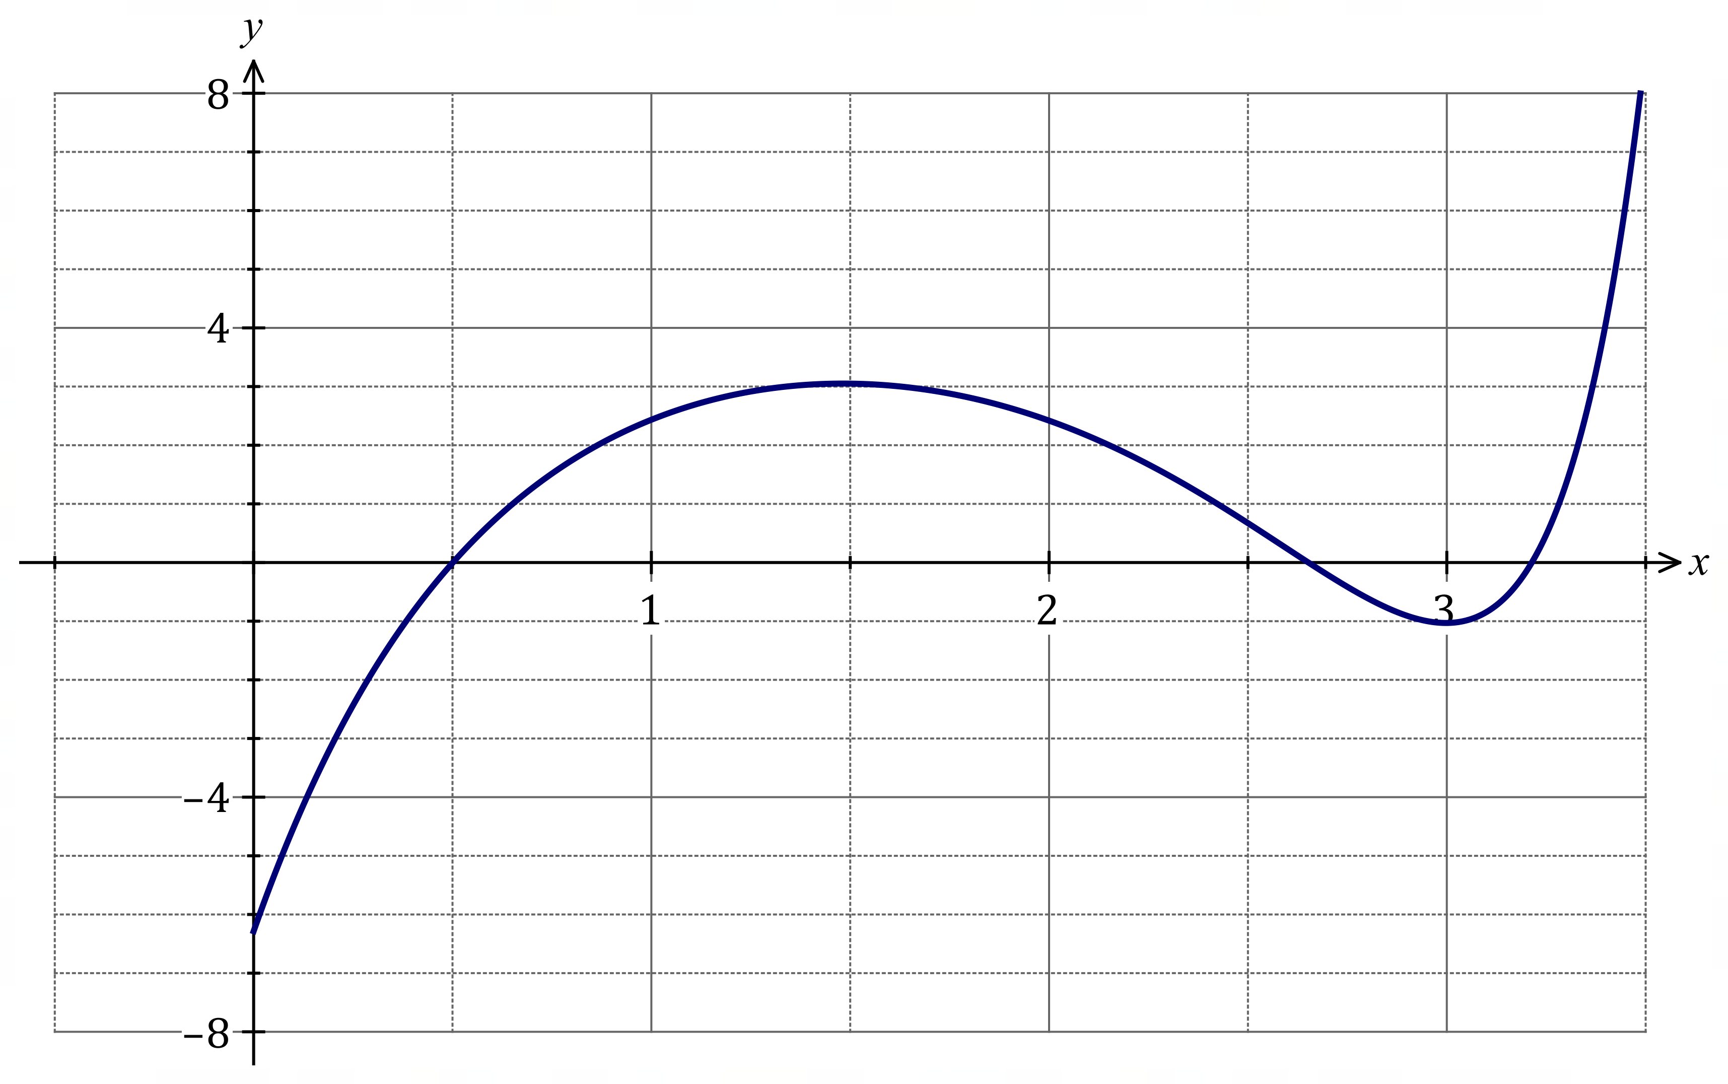
Min at (3,-1)
Max at (1.5, close to 3)
(0.5,0)
Solution
See graph.
Specific behaviours
ü correct location and curvature of local maximum and local minimum
ü y-intercept between $-8≤y≤-4$ and correct x-intercept of x = 0.5
ü correct curvature and steep for $x>3$

Question 5 (11 marks)
The diagram below shows the curve $y=e^{x}+2$.
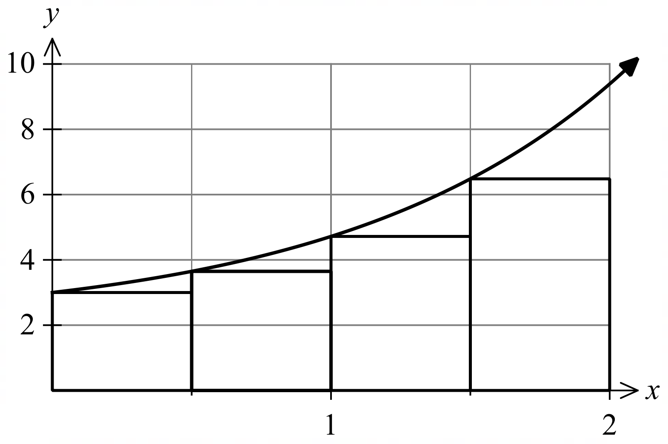
The coordinates of various points on the curve are given in the table below, correct to one decimal place.
$$x$$ | $$0$$ | $$0.5$$ | $$1$$ | $$1.5$$ | $$2$$
$$y$$ | $$3$$ | $$3.6$$ | $$4.7$$ | $$6.5$$ | $$9.4$$

(a) Calculate the missing value in the table. (1 mark)
Solution
$$y=e^{0}+2=3$$
Specific behaviours
ü Determines value.

(b) Using the rectangles shown in the diagram, determine an approximation of the
area under the curve, correct to one decimal place. (3 marks)
Solution
$$Lower sum=0.5\left(3+3.6+4.7+6.5\right)$$
$$=0.5×17.8$$
$$=8.9$$
Specific behaviours
- Uses the correct values.
- Adds the $y$ values correctly.
- Multiplies by $0.5$ and determines an approximation of the area.

(c) Show that an overestimate for the area is $12.1 units^{2}$. (1 mark)
Solution
$$Upper sum=0.5\left(3.6+4.7+6.5+9.4\right)$$
$$=12.1$$
Specific behaviours
- Gives a suitable calculation for the overestimate.

(d) Determine the exact area under the curve from $x=0$ to $x=2$. (3 marks)
Solution
$$A=\int_{0}^{2}{\left(e^{x}+2\right)dx}$$
$$A={\left[e^{x}+2x\right]}_{0}^{2}$$
$$A=e^{2}+4-\left(e^{0}\right)$$
$$A=e^{2}+3$$
Specific behaviours
- Writes down a definite integral to determine the area (including $dx$).
- Correctly integrates function.
- Substitutes in boundaries and determines area.

(e) Explain how you would modify the method you used in part (b) to get an approximation of the area that approaches the exact area obtained in part (d). (1 mark)
Solution
$$Reduce the width of the rectangles used,$$
$$and therefore use more rectangles to$$
$$improve the approximation.$$
Specific behaviours
- Gives a suitable explanation.
Note: Average is not accepted as this refers to part b, underestimate

(f) State which of the estimates in part (b) and (c) is closer to the area determined in part (d).
Justify your answer using a feature of the curve. (2 marks)
Solution
$$Underestimate in part \left(b\right) is closer to$$
$$the exact area determined in part \left(d\right).$$

$$The curve is concave up, hence the$$
$$underestimate is closer to the exact area.$$
Specific behaviours
- States the underestimate is closer to the exact area.
- Justifies choice using concavity of the curve as concave up

Additional working space
Question number: ________

